Work Sample for Future Games

For my work sample that I’m going to use to apply to Future Games I’ve decided to create a boss battle set in an arena. Why I’ve decided to do that is because I want to add interesting mechanics and interactions between the player character and the boss. Just having the one boss fight will drastically increase the quality and I can focus on making it dynamic and interesting. The game is going to be created in the Unity engine with C# and it will be a 2d game.

On the last page of this PDF I will include links to all project files, the finished game and to a video showing the game in action. I will also show screenshots of my code throughout this work sample PDF. The screenshots of the scripts will not be completed scripts and will be worked on over time during this project. The completed scripts will be available on the last page in my project files. I’ll comment on lines of code so that readers of this can understand my thought process more in-depth.
The first thing I’m going to create is the player character and the arena in Photoshop, I do this because having some of the visual elements present in Unity really helps me visualize how I’ll set everything up.
The next step for me is to give the character a player controller and I will be making my own script from scratch for that. For my character’s X axis movement I like to call the horizontal axis from Unity itself. To give my character velocity I get the
”RigidBody2D” and create a public float “speed” and adjust that value inside of Unity.

private void Movement(float horizontal)
{

rb2d.velocity = new Vector2(horizontal * speed, rb2d.velocity.y); }
This is how I get him to move on the X axis. So now that he moves left and right I start on the animations. I’m gonna animate everything using the skeleton animator inside of Unity. I created animations for running, jumping, sliding, idling and attacking. Which are the basics we need but I might change or remove things if needed.
I have to get the animator component into my script for me to be able to access it from the script. I then declare three boolean variables. “attack, sliding and jumping”. I do that so I can use “if statements” to trigger the different movement options. For the jump however I want to add an additional bool “isGrounded” I will use that to restrict various code from being able to be executed when the character isn’t grounded so we use that to prohibit jumps, attacks and slides while the character is not grounded. In the “if statements” I also tell the script to play the animations if the conditions are met.
For the jump I’ll not call on the Y axis from Unity but just add velocity to the characters Y axis. Like this:
if (Input.GetKeyDown(KeyCode.Space) && isGrounded)
{
jumping = true;
rb2d.velocity = new Vector2(rb2d.velocity.x, 15); }
I think It’s simpler to do so.
Now I’ve gotten the base of the player controller done. I’m gonna showcase the code in screenshots so it doesn’t take up too much space in the PDF.
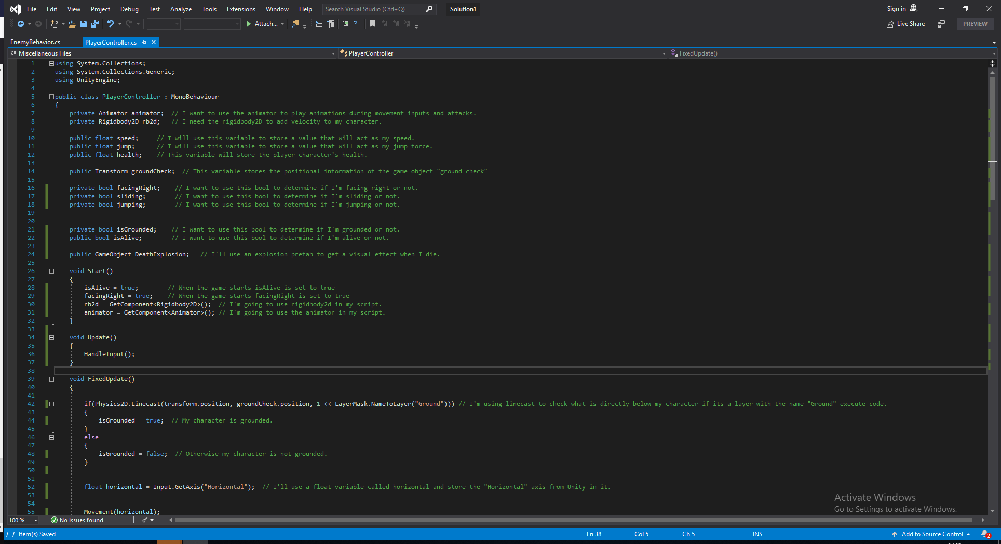
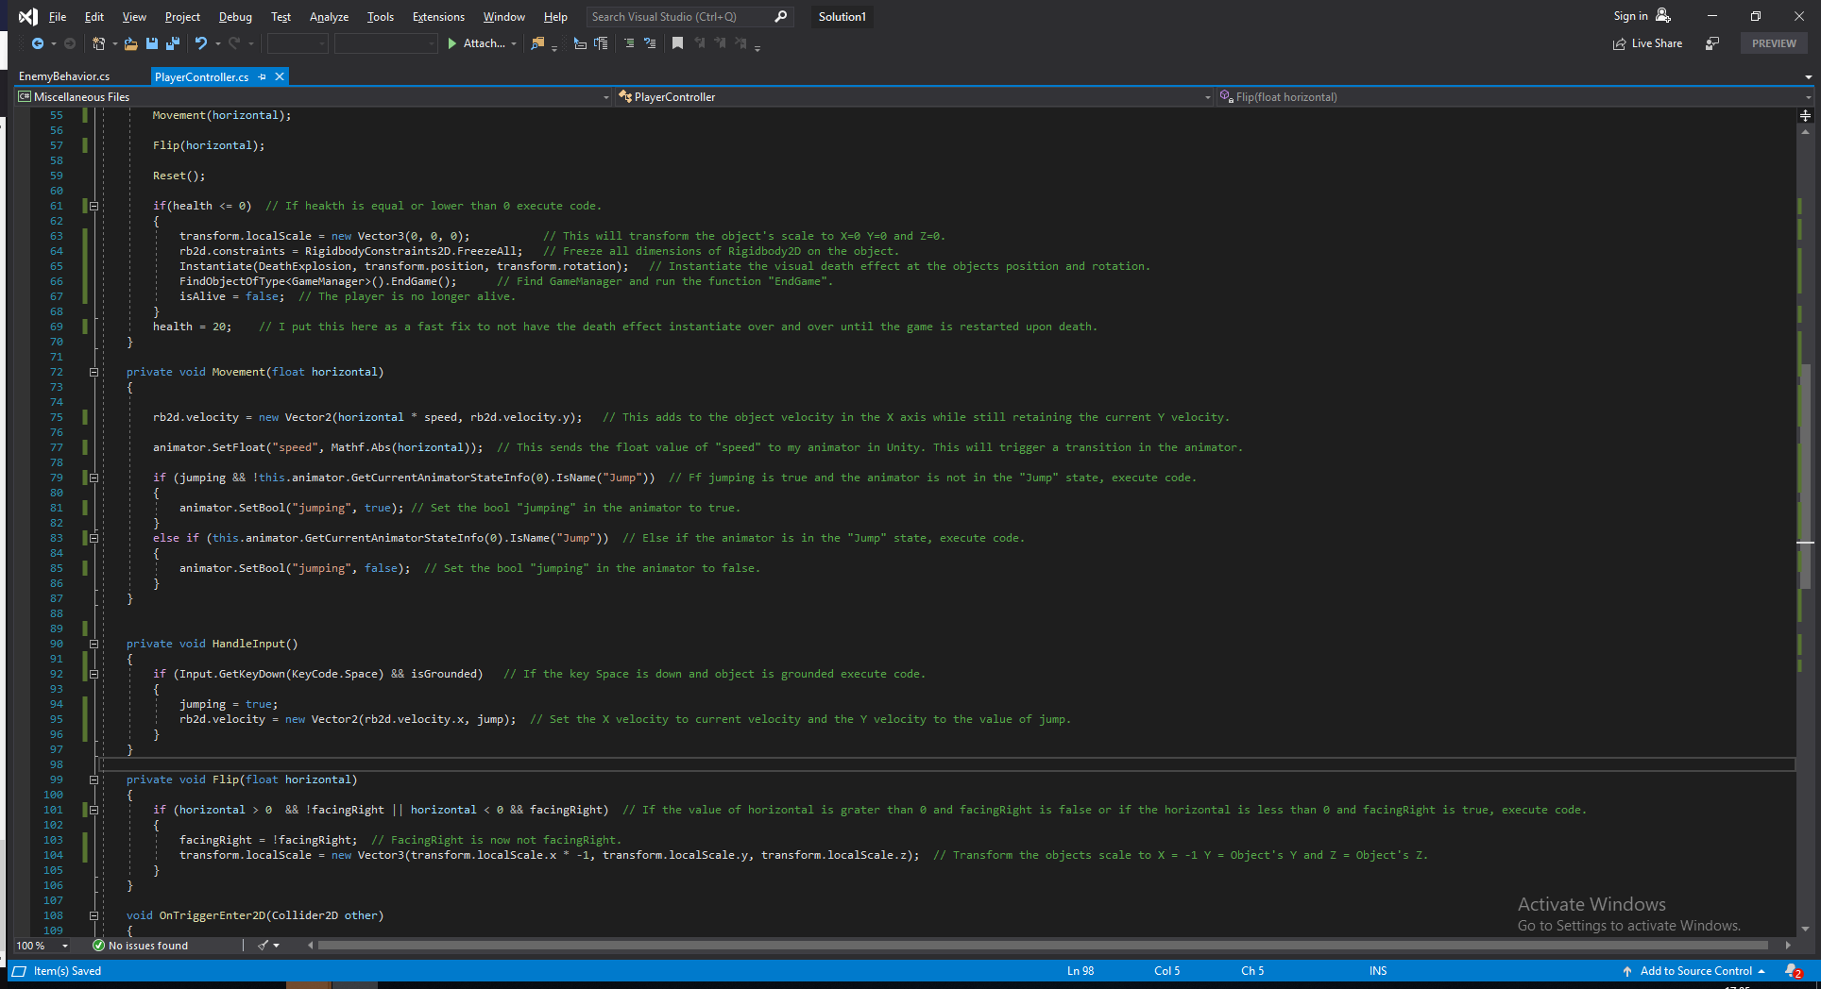
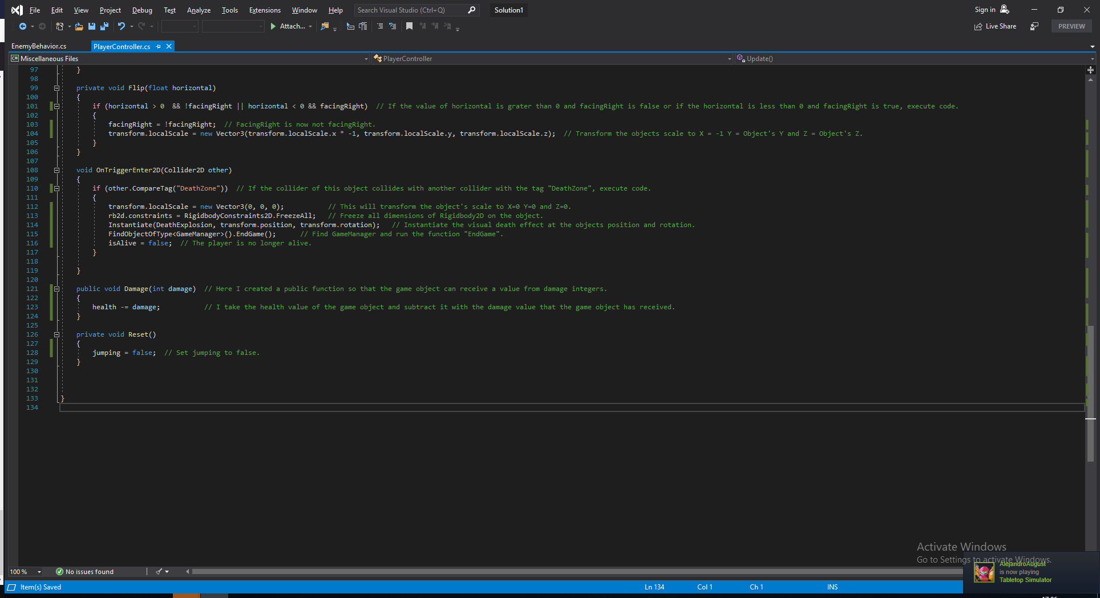

I now want to start working on the boss character so again I created his design in Photoshop and imported it into Unity for visual aid. First thing I want to code is some of my boss character’s behavior and I will do so in a script called “EnemyBehavior”.
First and foremost I want to make the boss follow the player character but at the same time not get too close! My boss is going to try to stay in the mid range because he is going to be a spell caster and use different spells from mid range. I will not show screenshots of the enemy behavior script as It’s a very long one. Instead look through the project files to see it.

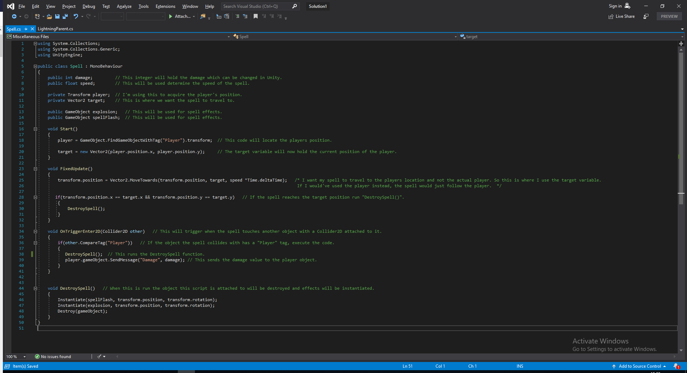
After I create some simple follow and retreat code I now want my boss to be able to shoot his first spell which is going to be a fireball. I will put the spawning of the spell in the enemy behavior script but the actual fireball will be created in a “Spell” script. I will also use the Unity particle system to give the fireball some particles when it is destroyed. This is the finished script.
I have a great idea for the next attack for my boss and the idea I have is to make the boss teleport away and then throw lightnings bolts onto the platform and have the player try to dodge these lightning bolts!

My idea is to have the enemy boss create an invisible game object that will have a script attached to it that spawns lightning bolts in random order. Why I decided to have a game object house the script to throw lightning bolts is because I want the boss to “teleport” away by changing the scale on him to 0 on X, Y and Z which could lead to some potential issues. I feel like it’s also easier to keep track of everything if I don’t put all code regarding the boss in one script.

After I’ve created all the visuals for the lightning bolts I start making the “lightning parent” script for my empty game object which will spawn the random lightning bolts that I want. My idea is to have five different lightning bolt prefabs in Unity that all have a different spawn point and target point and to make them randomized I just use an array and instantiate a random lightning bolt prefab. The lightning parent will grab a random lightning bolt and the lightning bolts themselves will hold the starting and target positions.

These are the finished lightning parent and the lightning bolt scripts.

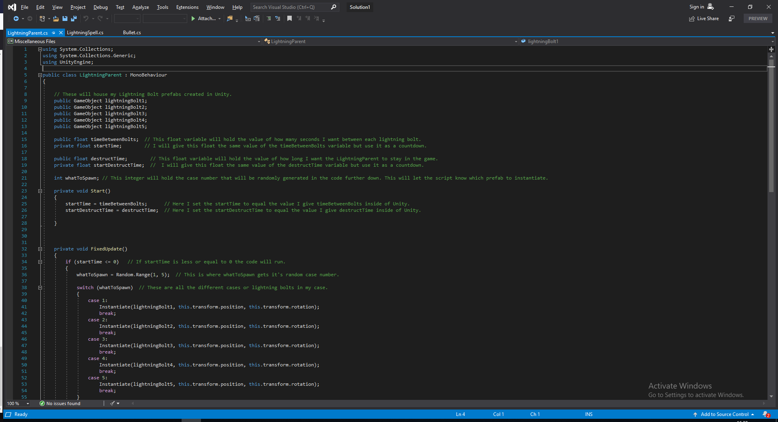

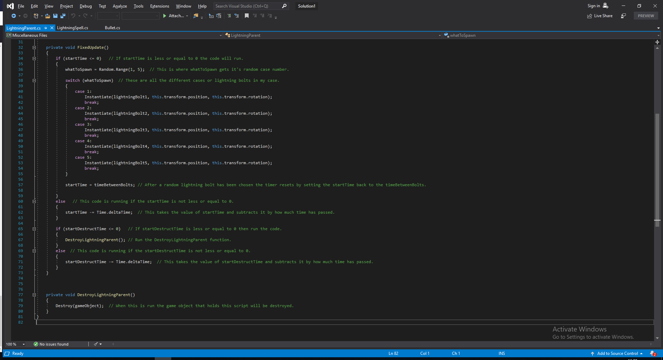

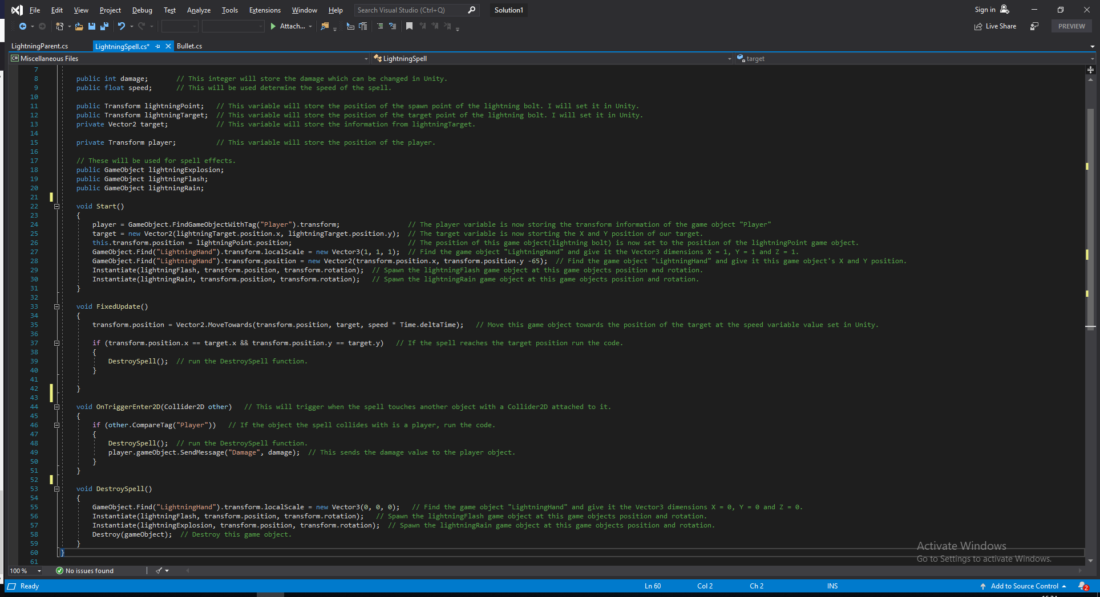

Now the fight is more dynamic! I got projectiles flying horizontally and a phase where lightning bolts travel vertically all over the the platform! The bolts are even random which makes it even more dynamic. To make the player aware of where the bolts are gonna strike I’ve made a phantom hand that pops up in the sky where the bolt is going to strike. The goal was to give the player a visual aid so that the bolts aren’t unfair.

I want one more mechanic in the boss fight to make it a real challenge! All bosses should pose a challenge to the player! My idea now is to add some flying minions that also have health and if they come into contact with the player the player dies.
I feel like that should make the fight even more fun which is my goal here.

I will code these minions in a very similar way I did with the lightning bolts. I want to create a game object from the boss that will act as a spawner of the minions. So the boss will after a set amount of time create the spawner that will in turn spawn the minions. I also want the minions to come from different angles that’s where I’ll put in some random number generation like in the lightning parent script. You could think of the minions as a mixture of the lightning bolt and the boss script. It will be random, it will target the player and it will travel towards its target just like the lightning bolt but it will at the same time have a hurtbox and have a health value just like the boss.

I’ve decided the minions to look like flying flaming skulls as I’ve been going for a very demonic and fiery theme with this game. So the skull parent script will look almost identical to the lightning parent script so instead of showing both the skull parent and the skull enemy script I’ll just show the skull enemy script which is the code for my flying minions.

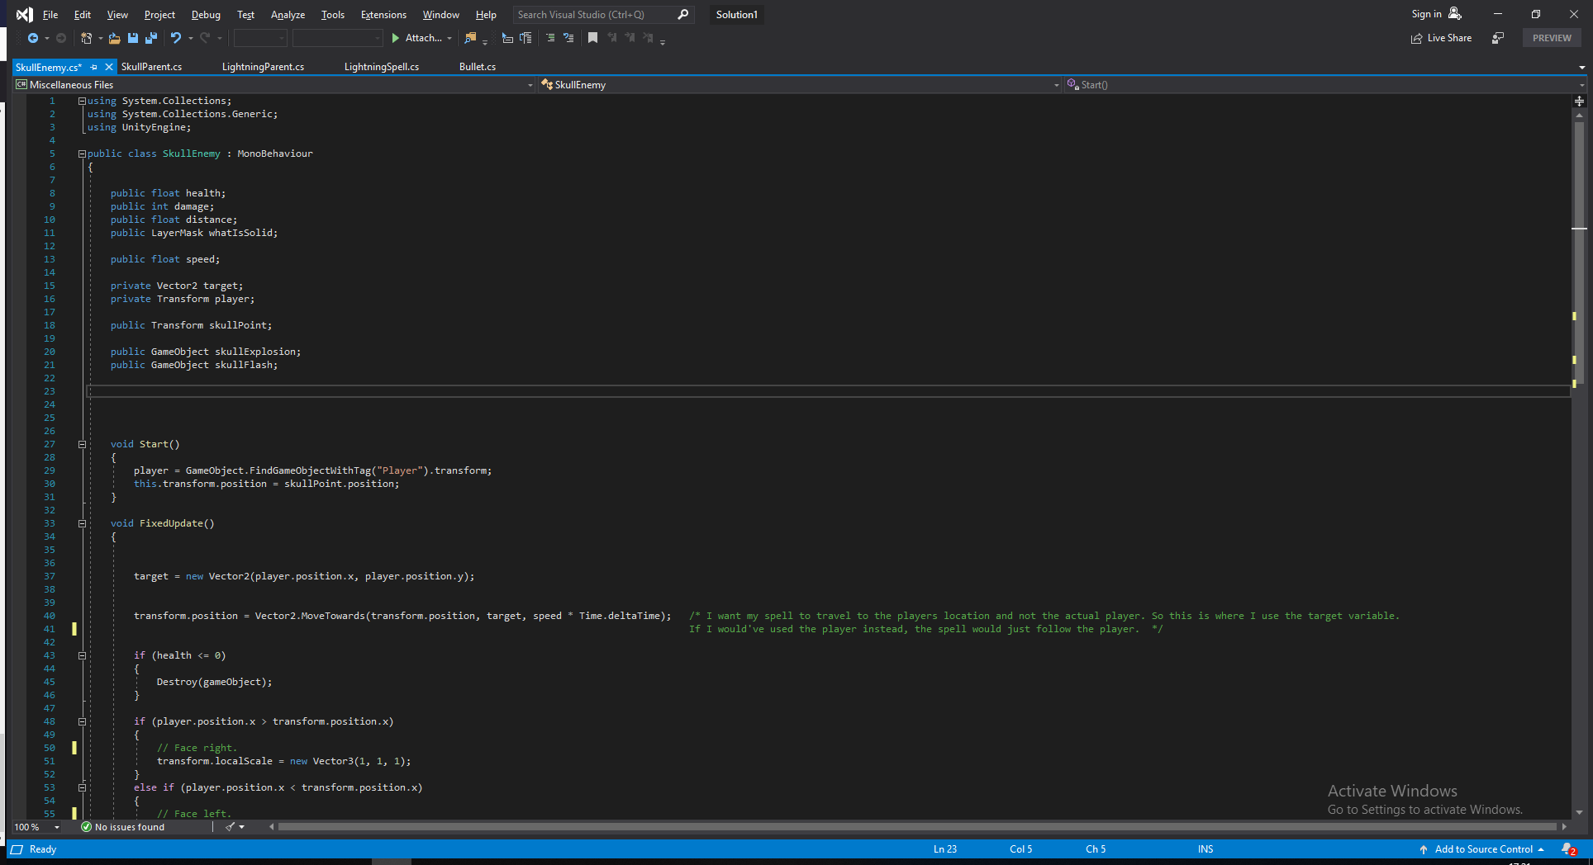
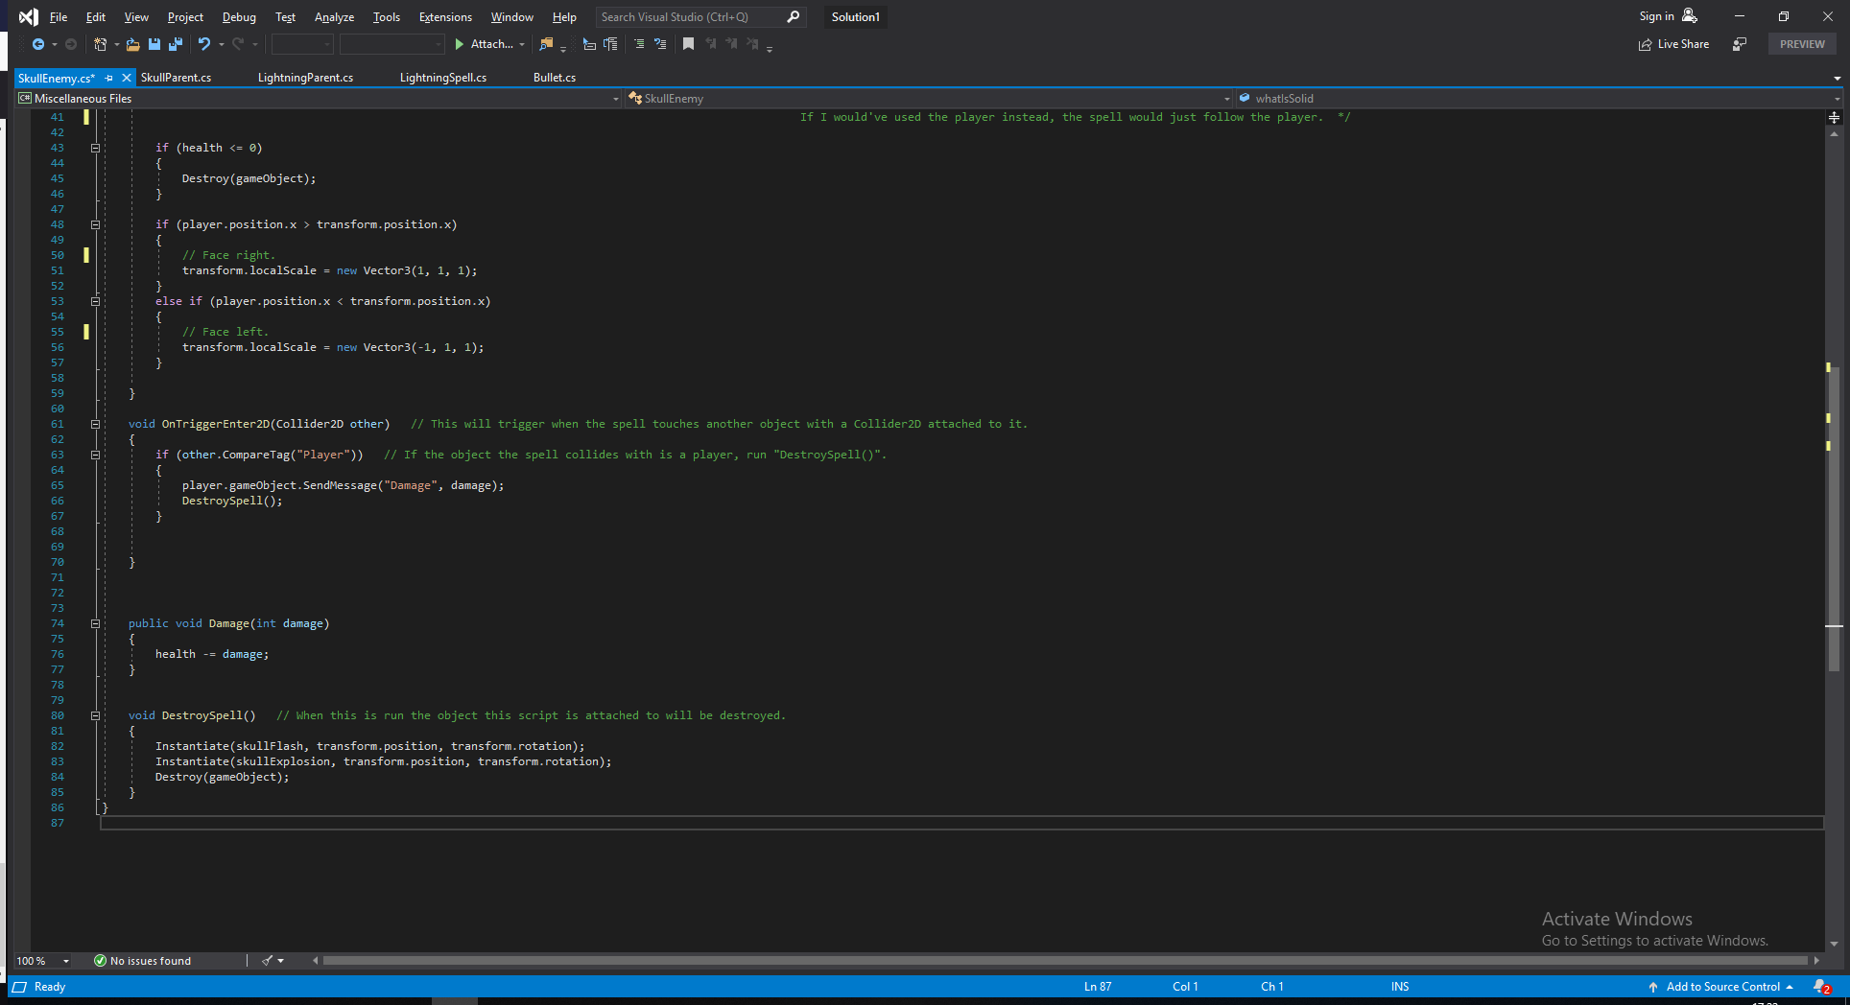

Now I consider my boss character done! I have several layers to the boss character in terms of gameplay and I now have to add things like a menu when you start the game. A cutscene when you start the game, some UI elements and a way for my character to attack! I’m going to use a ranged combat system for my player character because I started coding a melee system but I thought it felt sluggish and just didn’t feel good for my game. This game is more suited to having a ranged combat system for the player and so I’ll do that. I’m going to edit my players photoshop project file and remove his hand and sword. I’m going to create a new hand with a pistol attached, add it to Unity and give the gun a script of its own. The gun will aim where my mouse is and shoot whenever I click the mouse button. I was considering using a cooldown mechanic for the shooting like I have been using for my boss spells but it just feels better being able to shoot as fast as you can click with your hand.

This is the gun script called “LookAtMouse” because the main function of this script is to make the gun follow the mouse.

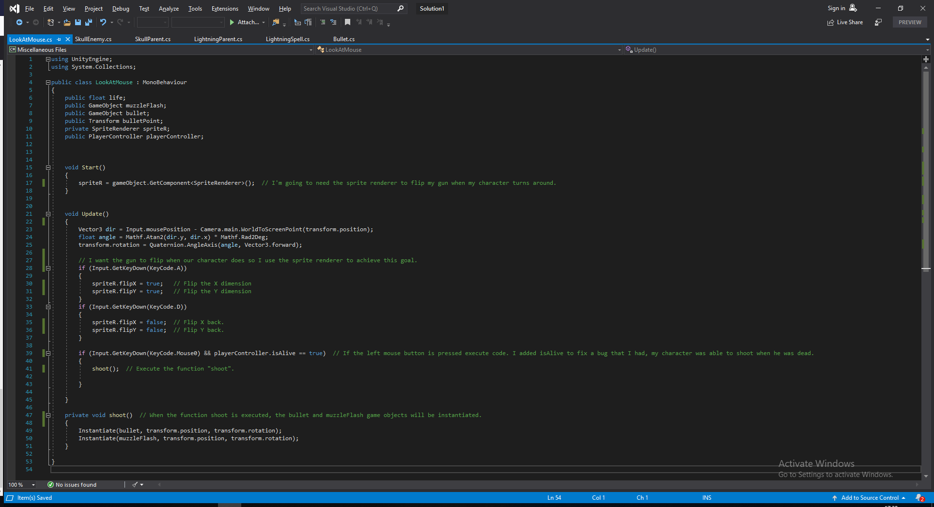
This is the bullet script.
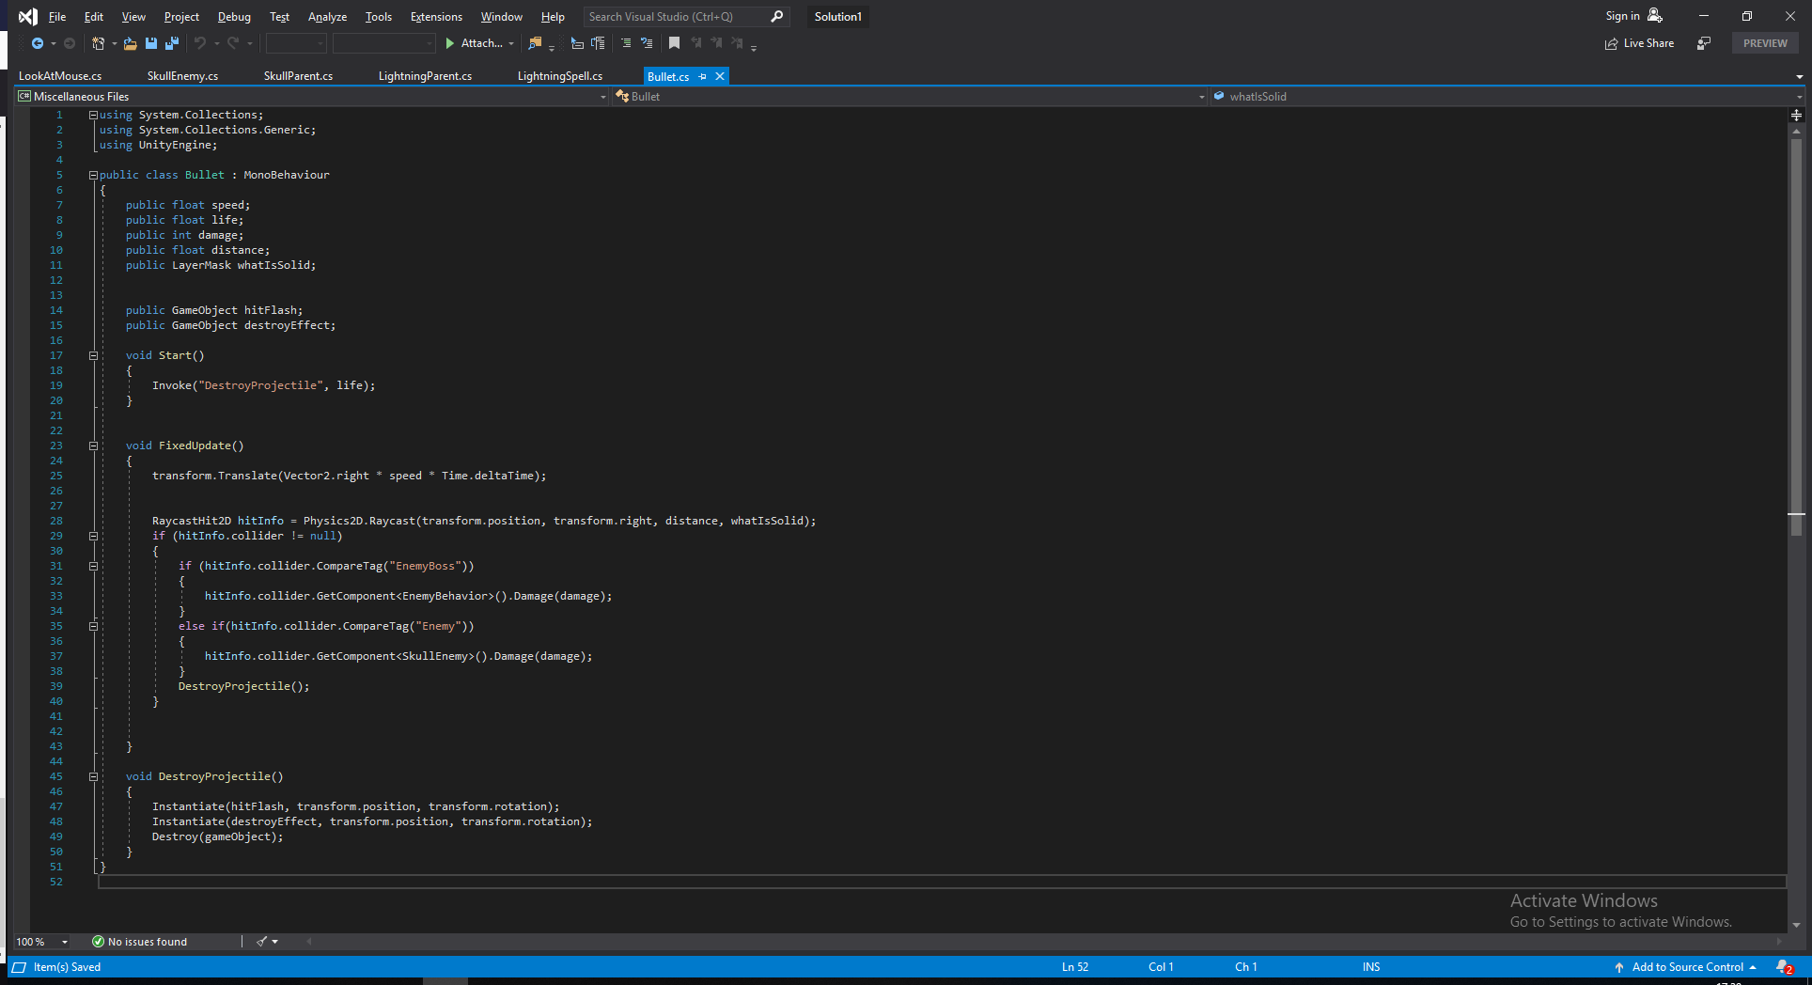

The bullet script functions very similarly to previous scripts I’ve written so I will not add any comments to the lines of code.

Now everything is working and we have an actual fully functional boss fight! I’m quickly just going to add an HP bar for the boss so the player can keep track of how close to dead the boss is.

The easiest thing to do between the cutscene and the main menu is the main menu, I’m going to add two buttons in a canvas, one for starting the game and one for quitting it. Here I’ll actually have to create a new scene and use the scene management that’s built into Unity to be able to switch between different scenes in the game.

When using scene management in Unity it’s pretty easy to load the next scene. You just get the active scene and than add a +1 to it to get the next scene in line. This is how you would write it.
public void PlayActive()
{
SceneManager.LoadScene(SceneManager.GetActiveScene().buildIndex + 1);
}

Very easy to remember after you do it once. The code to actually quit the game is even easier. You just tell it to quit the application, like this.
public void Quit()
{
Application.Quit(); }
I had a lot of issues actually coding the cutscene in my game. I wanted a simple text of dialogue under the characters and have the player hit enter to proceed to the next line of text. I’ve never done a dialogue system before so this was a huge challenge that I didn’t anticipate would be as troublesome as it was. I spent a few days trying out ideas I had and tweaking things but I couldn’t get it to work. I could get the text actually displaying in the game using a public string array. But the player could just spam enter to get through the text and several other issues popped up during this process.

I actually looked for help online for this one and someone pointed out to me that I could use “IEnumerator” and a coroutine to get things working. He helped me write this code so I won’t pretend that I did it all alone. This is definitely above my skill level. The dialogue script ended up like this.

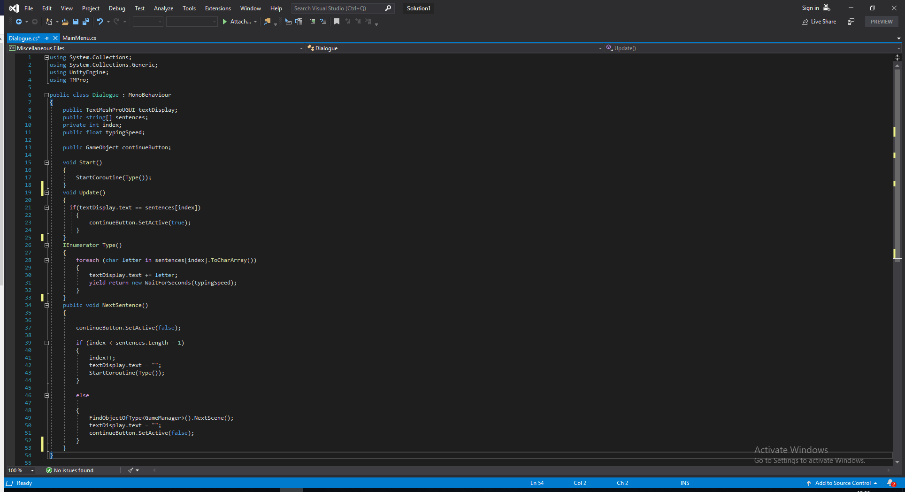

With this running we have a fully functional game with menus, a cutscene and the actual gameplay! It’s been a long project but I’m very satisfied with the end result. I wish I had more time so that I could develop different bosses and areas, maybe even an overworld. But with the time I had I’m more than happy with it! Like I said I’m going to include links to all project files and a link to a video on the last page!

Finished game:
https://drive.google.com/open?id=1PXvyn0gm1NSAPD05Aik8dEJKK4afDbGl

Project files:
https://drive.google.com/open?id=14huPj-1xh9Y9o5Ml-5vbM1zGVQW51it1

Youtube video showcasing the game: https://www.youtube.com/watch?v=8Hm1A0U0eHc&feature=youtu.be

